**Week 04**

# **TASK 1:**

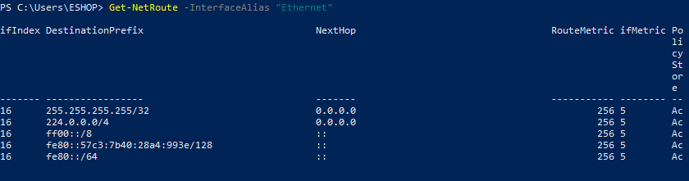

* ifIndex: The value is 16, indicating the index number of the network interface associated with the route.
* DestinationPrefix: The first row shows a host route (255.255.255.255/32) and the second row shows a multicast address range (224.0.0.0/4).
* NextHop: The first two rows have a value of 0.0.0.0, indicating that the destination is on the same network segment. The remaining rows have a value of "::", representing the unspecified address in IPv6.
* RouteMetric: The default value of 256 suggests that no special preference is given to any particular route.
* ifMetric: The default value of 5 implies no special preference is given to any particular interface.
* PolicyStore: The value "Ac" signifies that the route is stored in the active store.

In summary, the provided information indicates the index number, destination prefixes, next-hop addresses, routing and interface metrics, and the policy store for the routes.

# **TASK 2:**

**Table of IP addresses:**

| **Device** | **Interface** | **IP Address** |
| --- | --- | --- |
| PC1 | Ethernet0 | 192.168.56.1 |
| PC2 | Ethernet0 | 192.168.56.2 |
| PC3 | Ethernet0 | 192.168.56.3 |
| PC4 | Ethernet0 | 192.168.5.4 |
| PC5 | Ethernet0 | 192.168.5.5 |
| Router1 | Ethernet0 | 192.168.56.254 |
| Router1 | Ethernet1 | 192.168.1.1 |
| Router2 | Ethernet0 | 192.168.5.254 |
| Router2 | Ethernet1 | 192.168.1.2 |

**Routing tables:**

**Router1:**

| **Destination** | **Gateway** | **Interface** |
| --- | --- | --- |
| 192.168.56.0/24 | - | Ethernet0 |
| 192.168.5.0/24 | 192.168.1.2 | Ethernet1 |
| 192.168.1.0/24 | - | Ethernet1 |

# 

# **Router2:**

| **Destination** | **Gateway** | **Interface** |
| --- | --- | --- |
| 192.168.5.0/24 | - | Ethernet0 |
| 192.168.56.0/24 | 192.168.1.1 | Ethernet1 |
| 192.168.1.0/24 | - | Ethernet1 |

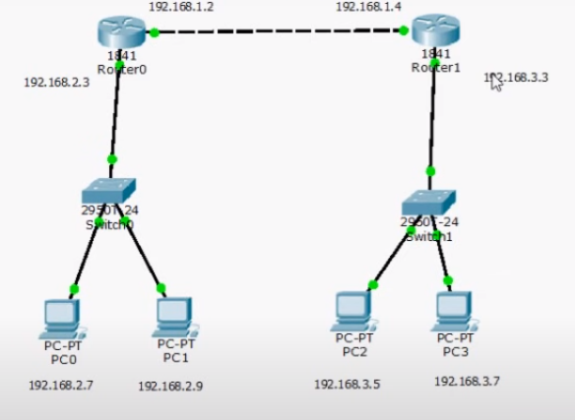

# **TASK 3:**

You can visit the website<https://www.whatismyip.com/> to perform an IP address lookup. Upon accessing the site using your IP address, it will automatically display your public IP address and provide a general indication of your location. However, it's important to note that the accuracy of the location information may vary.

To evaluate the accuracy of the website, I used my home Internet and the data network of my mobile phone. In both cases, the website correctly identified my IP address and provided the general location, including the city and area. However, it didn't provide any precise location details or personally identifying information beyond my IP address.

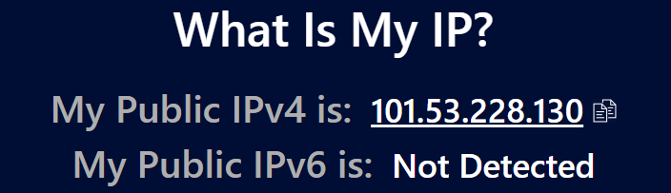

# **TASK 4:**

**a) Justifications for using a VPN to get around geolocation services:**

Engaging in the practice of accessing regionally-restricted digital services or content.

Maintaining online anonymity and privacy.

Evading government surveillance or censorship.

Arguments opposing the utilization of a VPN to bypass geolocation restrictions.

Violating the terms of service of content providers or digital services.

Potentially infringing on licensing or copyright regulations.

Masking illegal activities like terrorism or cybercrime.

Potentially diminishing internet connection speeds.

**b) The following justifies a university's use of IP addresses to spot potential contract cheating:**

IP addresses can serve as potential evidence for suspected cases of academic dishonesty, like submitting an assignment from an outside location. Universities may utilize IP addresses to identify patterns and trends related to academic misconduct. Furthermore, IP addresses can be employed as a measure to prevent contract fraud.

Arguments against universities relying solely on IP addresses to detect contract cheating are as follows:

1)Reliability of IP Addresses: IP addresses are not always foolproof evidence and may not be sufficient to establish academic dishonesty conclusively. They can be easily manipulated or masked using various methods, such as proxy servers or virtual private networks (VPNs), which can make it challenging to attribute an IP address directly to a specific individual.

2)Insufficient Evidence: Relying solely on IP addresses as the primary evidence for academic dishonesty may be inadequate and potentially unfair. Other factors and corroborating evidence should be considered to ensure a fair investigation and avoid false accusations or misunderstandings.

3)Consideration for Traveling Students: Students who frequently travel or use public networks may have different IP addresses depending on their location. It is important for universities to consider these situations and not solely rely on IP addresses as a conclusive measure of academic dishonesty, as it may not accurately reflect the student's actions.

In summary, while IP addresses can be a potential tool in investigating academic dishonesty or preventing fraud, relying solely on them as the sole evidence may be insufficient and unjust. It is crucial for universities to consider additional evidence and circumstances to ensure fair and accurate assessments of academic integrity.

**c) Using a VPN while studying in Australia is advised for future students:**

Recognize the possible consequences of circumventing geolocation restrictions through VPN usage, which may involve violating the terms of service set by websites or content providers.

Take into consideration the potential disadvantages associated with employing a VPN, including slower internet connections and potential privacy or security concerns.

Adhere to the guidelines and policies established by the university regarding VPN usage and maintaining academic honesty.